Setup Jenkins pipeline and configure docker cloud in that.

1. Create one instance.
2. Connect it to mobaxterm and install docker

Connect instanse from mobaxterm using SSH client

sudo apt-get update && sudo apt-get install ca-certificates curl gnupg lsb-release

curl -fsSL https://download.docker.com/linux/ubuntu/gpg | sudo gpg --dearmor -o /usr/share/keyrings/docker-archive-keyring.gpg

echo "deb [arch=$(dpkg --print-architecture) signed-by=/usr/share/keyrings/docker-archive-keyring.gpg] https://download.docker.com/linux/ubuntu $(lsb_release -cs) stable" | sudo tee /etc/apt/sources.list.d/docker.list > /dev/null

sudo apt-get update && sudo apt-get install docker-ce docker-ce-cli containerd.io

sudo docker --version

1. Install JDK

sudo apt-get update && sudo apt install default-jdk -y

1. Install maven

sudo apt-get update && sudo apt install maven -y

1. Install Jenkins

> curl -fsSL https://pkg.jenkins.io/debian-stable/jenkins.io.key | sudo tee /usr/share/keyrings/jenkins-keyring.asc > /dev/null

>echo deb [signed-by=/usr/share/keyrings/jenkins-keyring.asc] https://pkg.jenkins.io/debian-stable binary/ | sudo tee /etc/apt/sources.list.d/jenkins.list > /dev/null

> sudo apt-get update && sudo apt-get install Jenkins –y

>sudo service jenkins start (start jenkins)

>sudo service jenkins status (see the status of Jenkins)

Press ctrl+c

>sudo cat /var/lib/jenkins/secrets/initialAdminPassword (copy password)

>open publicId:8080 in browser

>enter intital password > install suggested plugins

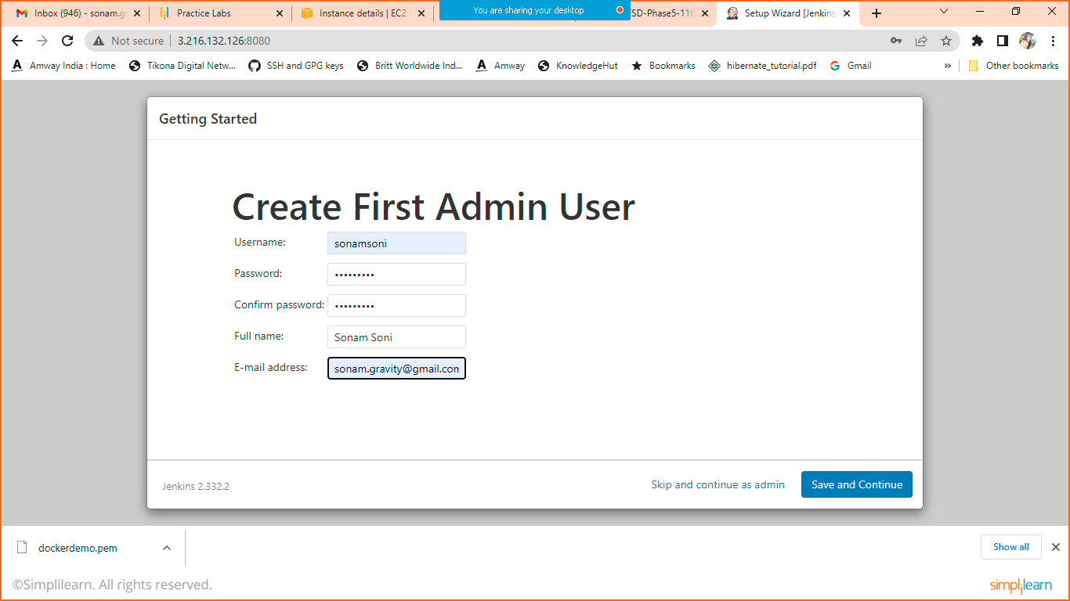

Enter details and click on save and continue

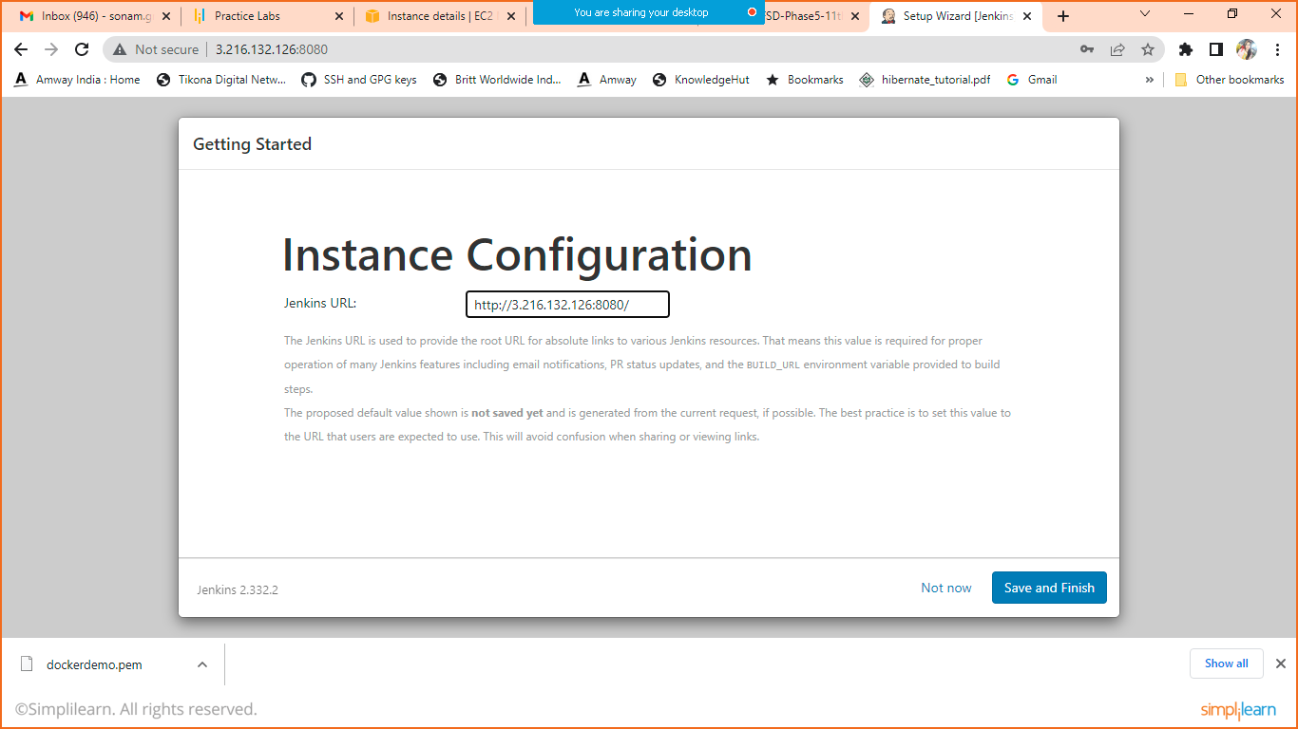

Click on save and Finish

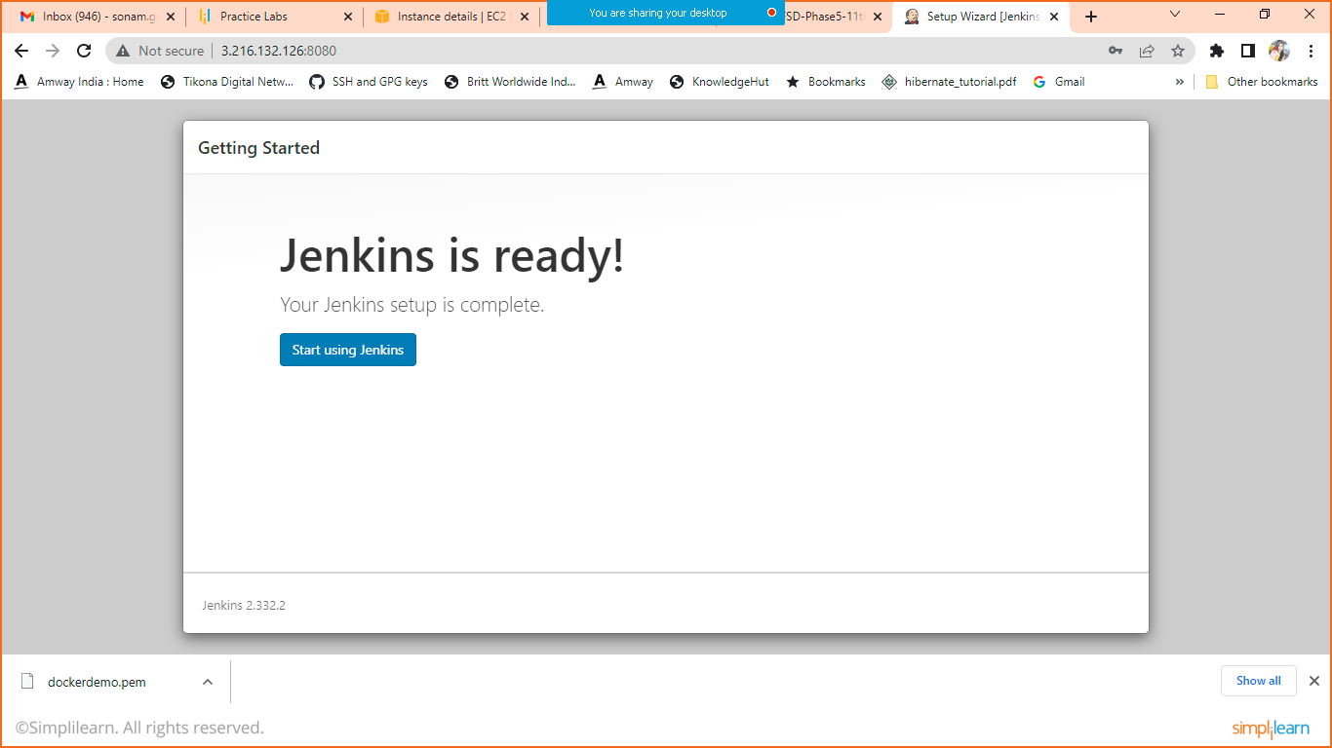

Click on start using Jenkins

This is your Jenkins Dashboard

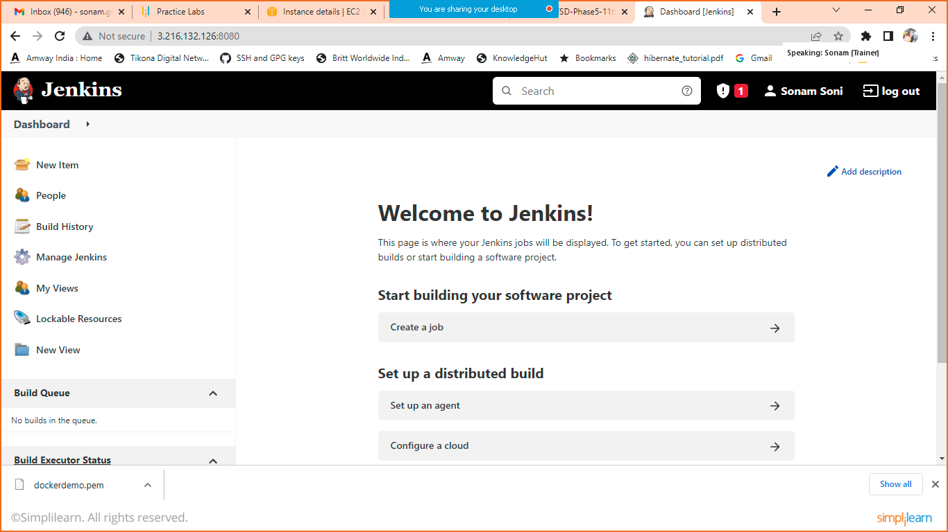

1. Install docker Plugin

Click on manageJenkins > manage plugins > available >search for docker plugin

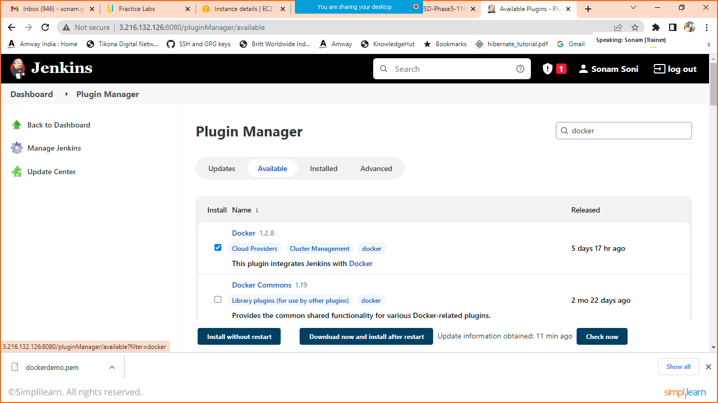

Select Docker and install without restart.

Go back

1. Configure docker cloud in Jenkins

Click on manageJenkins > click on manage nodes and cloud > click on configure cloud (left hand side)

Click on add new cloud > select docker

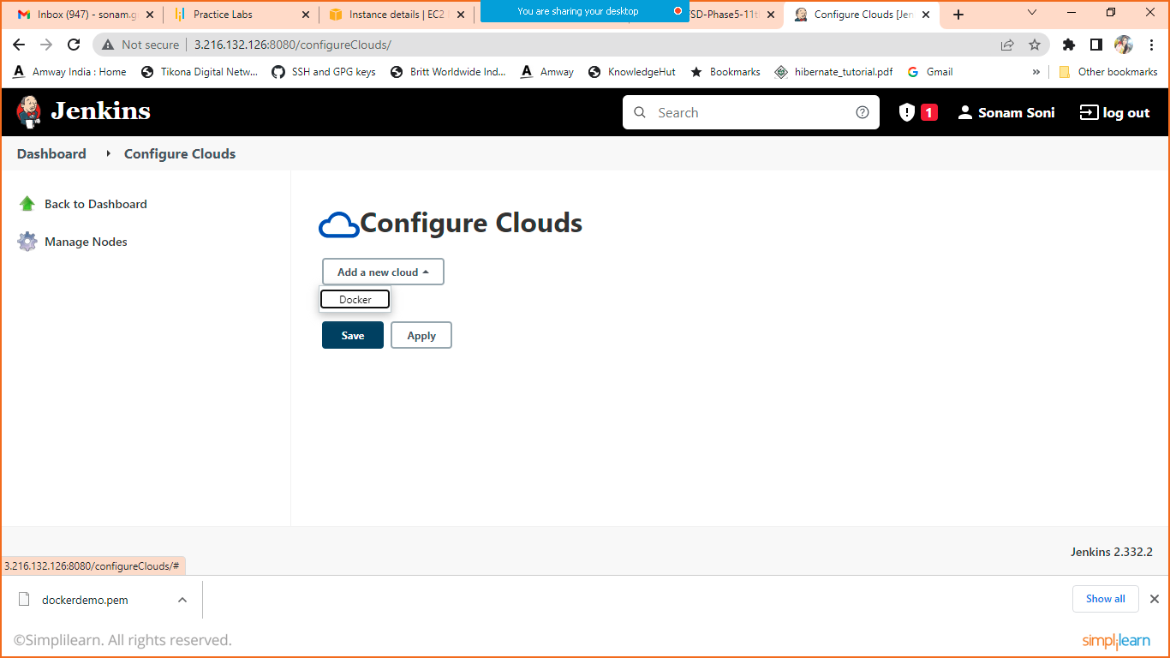

When you click on docker you will get below mentioned screen.

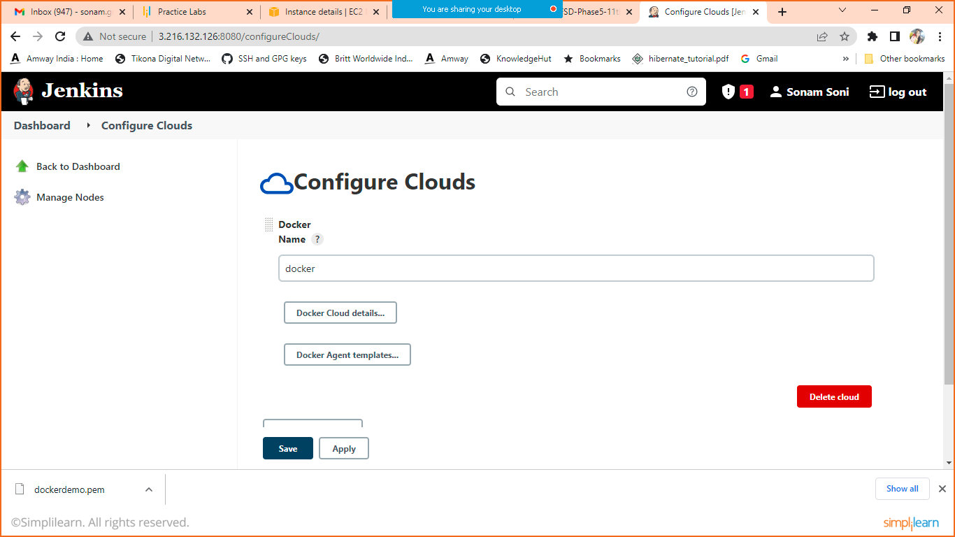

Click on docker cloud details and enter HostURI

unix:///var/run/docker.sock

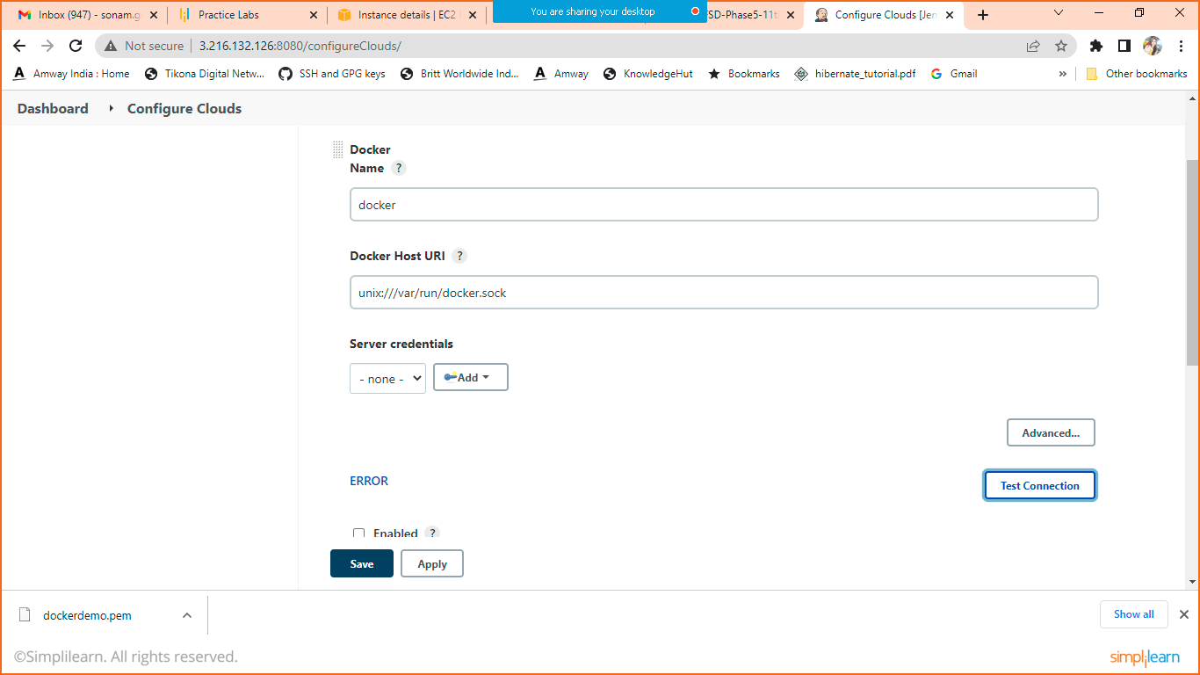

Click on test connection and check are you getting connection or Error

If error then go to your cli and execute below mentioned command.

sudo chmod 777 /var/run/docker.sock

refresh then check again.

1. Create Pipeline
2. Click on new item > project name(Jenkinspipeline) > freestyle Project> OK
3. Give description

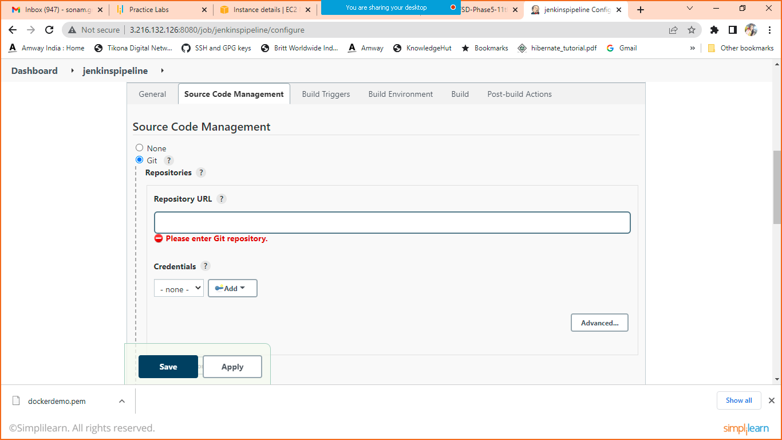

Enter Git URL

Change branch name

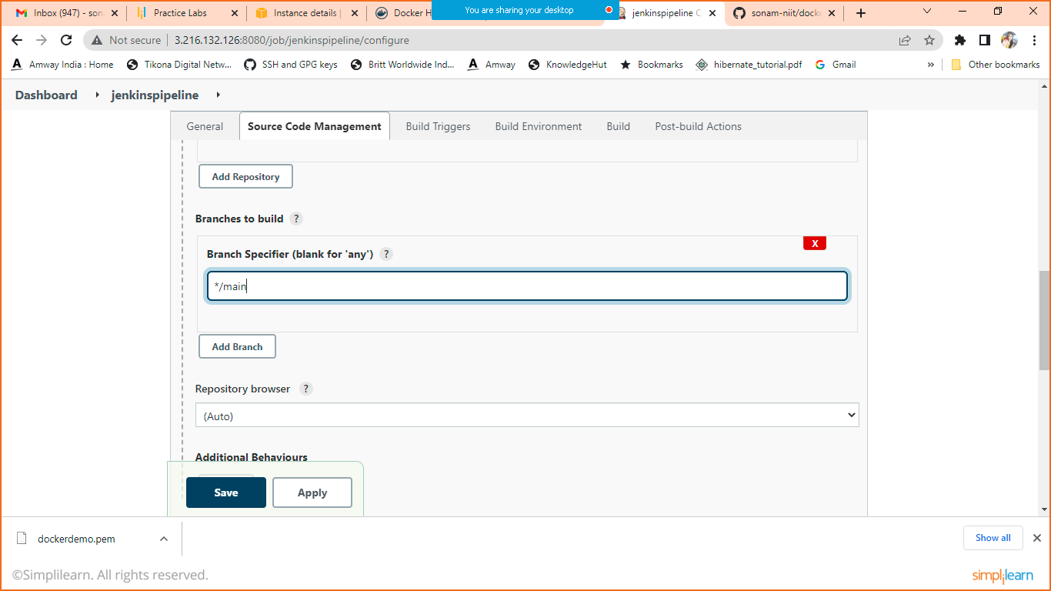

Schedule the build using Poll HCM

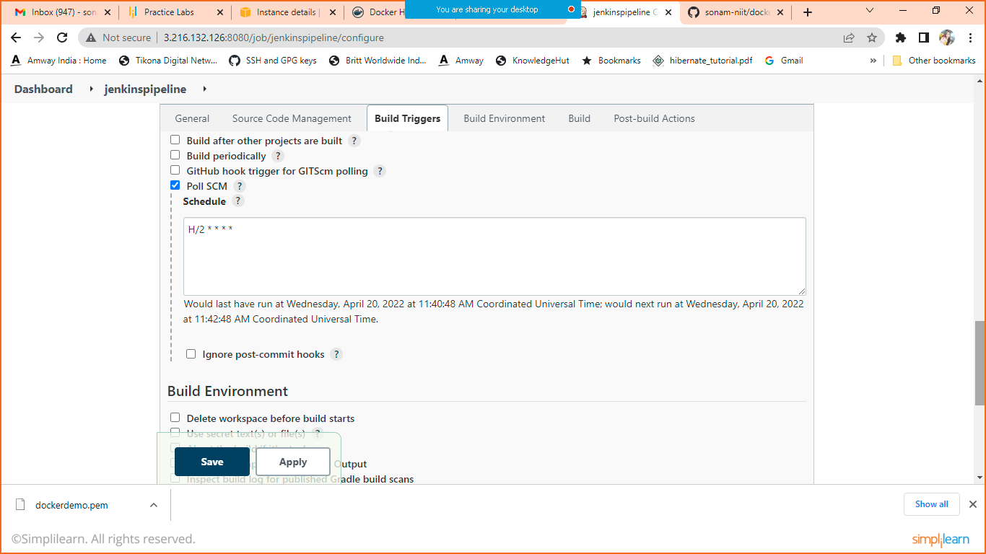

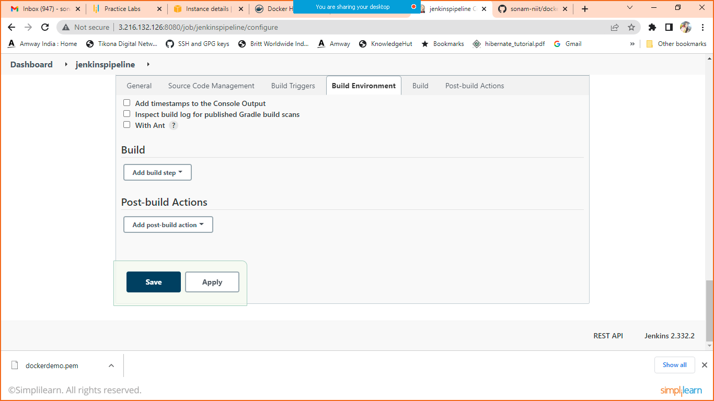

Click on Add Build Step

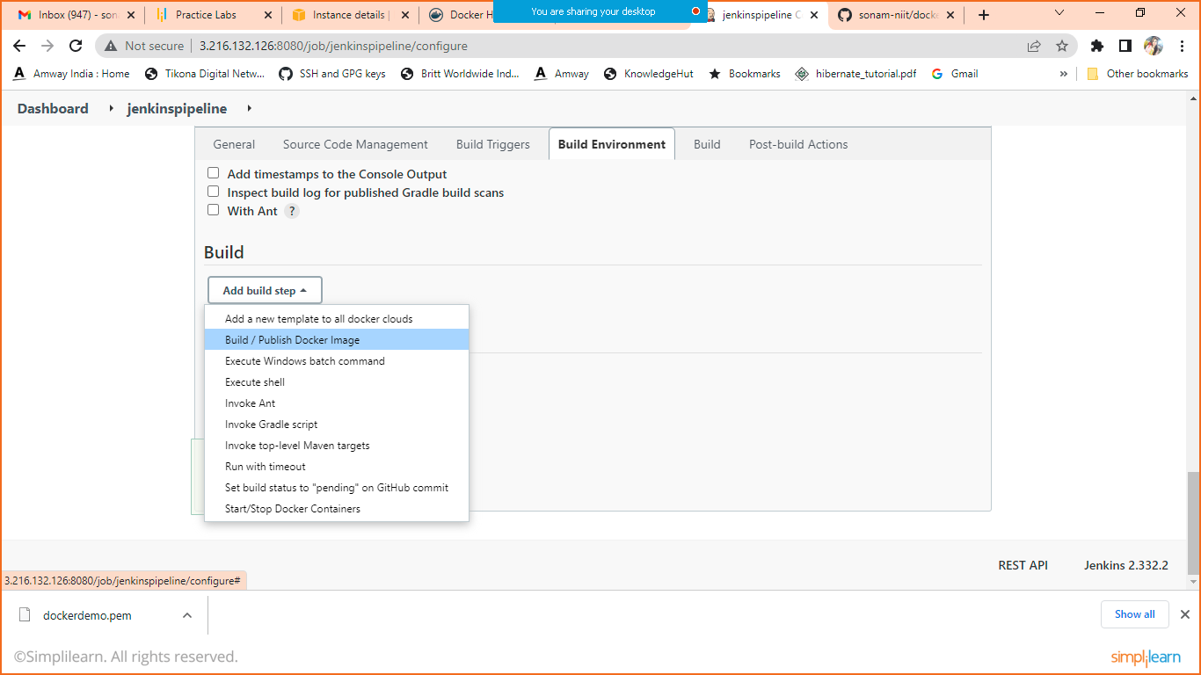

Click on build and publish docker image.

Keep directory for docker file blank as we have dockerfile in root folder only

In cloud

Select docker

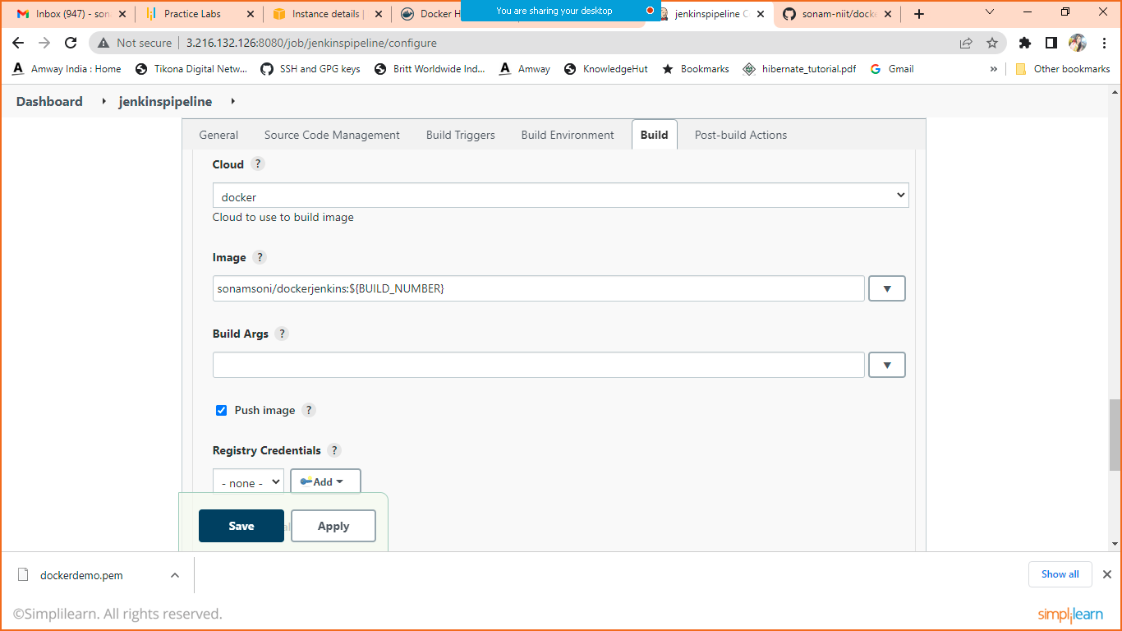

Give the image name and click on push image too.

Click on Add to add registry credentials

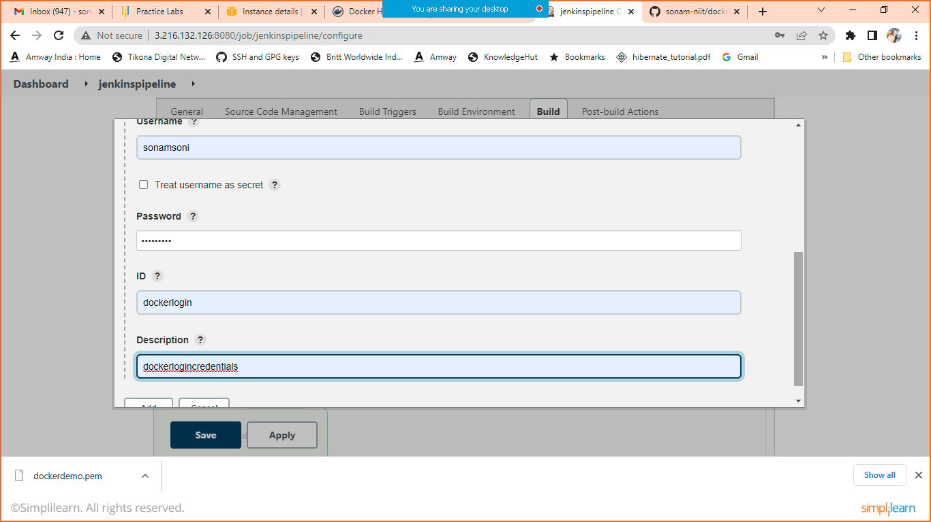

Give your docker hub credentials

Select created login from registry credentials

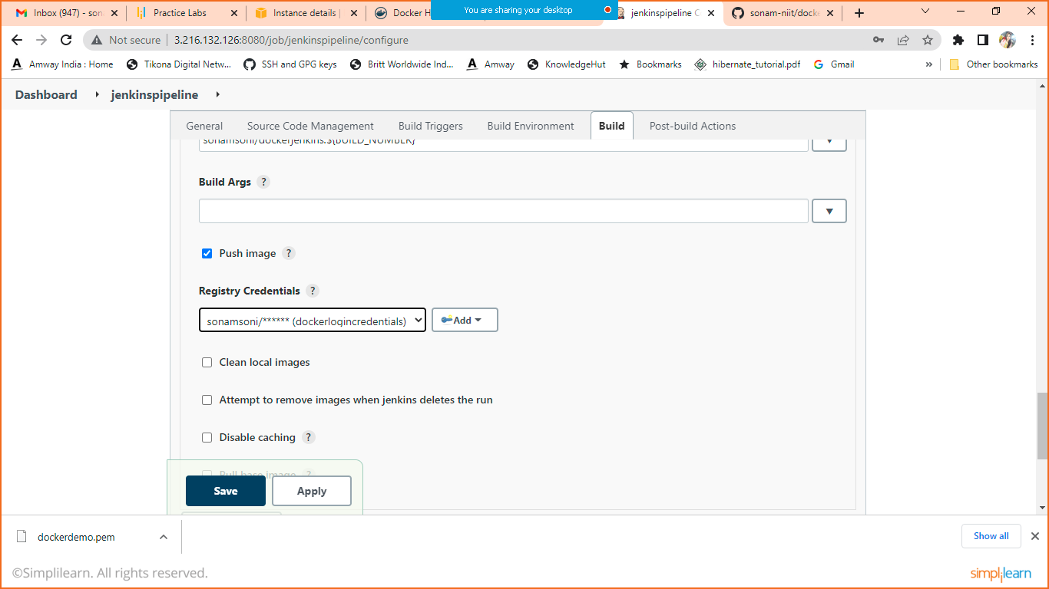

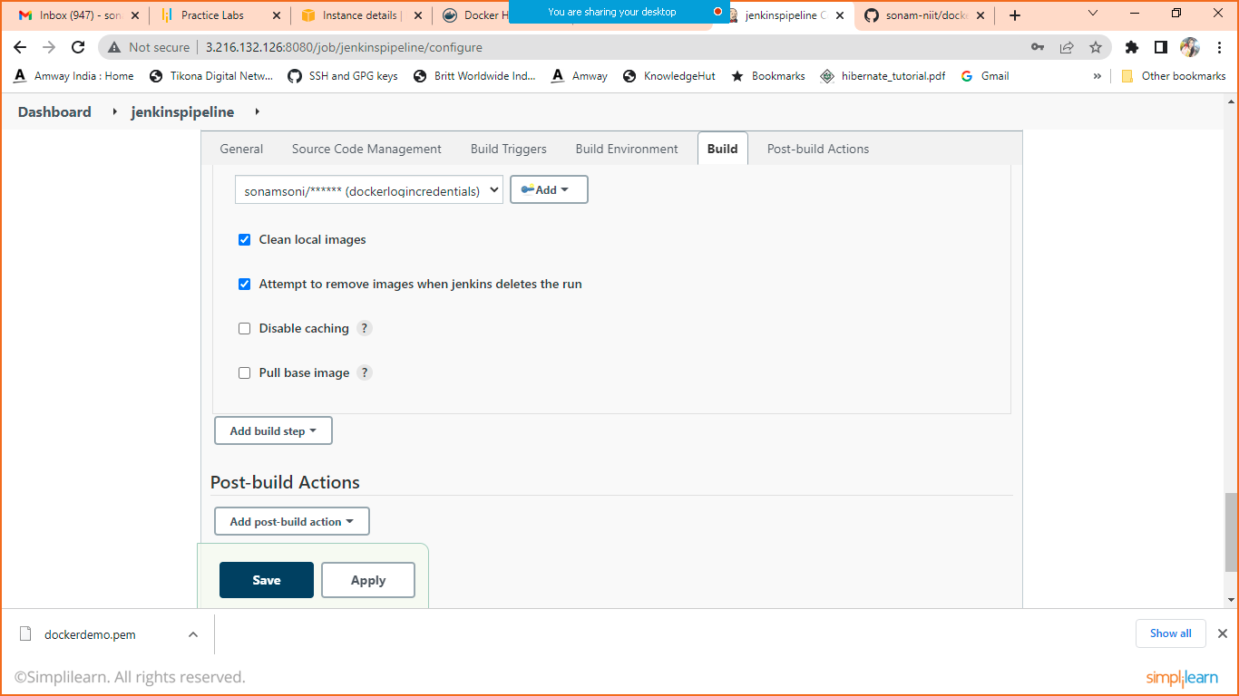

Apply and Save.